Richard Highwalker Ministry
Fire Tribe Global Academy
www.RichardHighwalker.com
405-938-7159

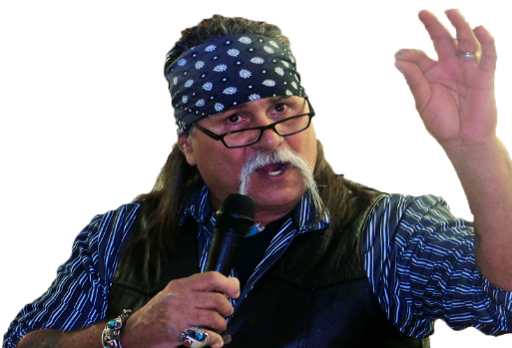
Richard Highwalker Apache bloodline, Apostolic –Evangelist and Co-founder of Freedom Fire Ministry, Inc Richard Highwalker Ministry, Chosen Daughters International, Inc, And Blood Brother’s Ministry. He is as well Director of Overcomers since 2005. He is a part of the Blaine County Drug court team in Watonga, Ok. He hosts Smoke Signals on Facebook life online. Richard has been a visual illustrator, artist for miracle hands productions art studio. And an author of his first book "Christ anointed garage". His artistic abilities due to the lord's good grace all inspired by the holy spirit. The holy spirit, alone, gave Richard the ability to see the heart and his passion in which he desires to bring to all the earth. Richard gains the lord's eyesight and manifest his talent on paper to illustrate what the world need to see and hear from the father.
Richard is a celebrated Author and Teacher of God's word. He is married to the love of his life Kristi Highwalker who he walks in all aspects of ministry and life with. He has 4 children an 7 Grandchildren. All of the Ministries under the Umbrella of FFM are under the covering of Apostle Ryan Lestrange..

In the love of the Father
Richard Highwalker

