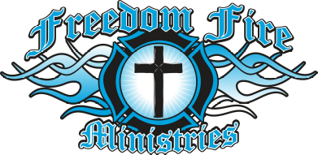

Richard & Kristi Highwalker
P.O. Box 350
Calumet, Ok 73014

Phone:
580-660-5375

Email:
kristi@freedomfireministry09.com

Web Page: www.freedomfireministry09.com
Check us out on Facebook!
www.facebook.com/highwalkers
www.facebook.com/freedomfireministry

2nd Corn 3:17-Luke 4:18
Smoke Signals online every Monday
Fresh Fire Online Mon- Fri

To Book the ministry to have the Highwalkers come to your church please contact Kristi Highwalker at 405-358-FIRE

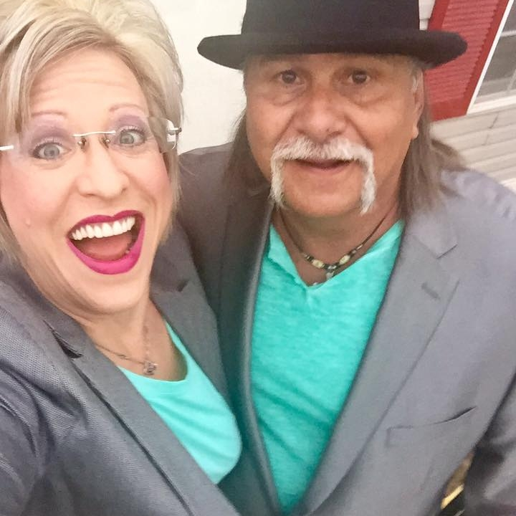
Richard and I welcome each of you to the New FFM Newsletter that goes forth each month to our amazing partners, and all who request to receive the newsletter. It has been amazing to watch how the Father has placed a writer anointing upon our lives, and with that be ready each month to receive for the heartbeat of the father what he is saying in this hour. We here at FFM have some HUGE announcements, and we wanted to start here with you our amazing partners to bring the unveiling of all the Fathers doing through us and FFM… so lets start revealing now.. We are coming forth with pure hot of the press releases that will set your church / ministry / prison/life on fire for the end time truths. The Father has commissioned us in this hour to anoint and appoint, to raise people, to unlock them, to arrange and call forth the gifts and calling out of the people for this end time days we are now in. To deliver a NOW word into the dry land. We are called to love and believe in those who can’t believe in themselves. To bring the well of the Lord to the dry places on earth and with that said, three very new impacts in which he is using us to water the earth are:
- Smoke Signals by Richard,. You can watch via Freedom Fire ministry’s or Richards personal Facebook page. We usually have each broadcast up around 10am. They will be posted on our webpage also If you want to be notified of each broadcast you can ask to join the private group Smoke Signals.
- Fresh Fire Online LIVE broadcast. With Kristi Highwalker, which broadcast live Monday thru Friday every week. Bringing a now word into lives which will be jammed packed with Revelation and unlocked insight from the Lord to bring one deeper into the heart of the Father. Teaching how to live a daily life IN HIM…
- From the Prisons to the Pulpit: This is the much-awaited book of the life story of Kristi Highwalker. How the Father brought her completely out of 8 major prisons in which she was bound in a matter of 8 short years. When one thinks of prison, we think of Jail, but there are other things in life that place us in prison, it is just those bars are invisible. I share my life story and the plans and patterns in which the lord gave me to come out and not be just delivered but totally restored in each prison. This book will touch the lives of so many people. No matter if you are have been, abused, abandoned, suffered Divorce, suffered loss / death of a loved one, rape, prison, addiction, loss of parental rights of children, this book is for you! You will find more information below in this newsletter…

Heartbeat of the Father 5778/2108
I have been receiving for 5778/ 2018 The Great Reaching Of The Outcast ( kicked out, banished, wounded) Going after the scared and bared, this will be the harvest of which we shall see a huge gathering in. Thrusted for by the power of the Thrust of Love.

There is coming into action the right place at the right time= alignments for this gathering. There have been times of strengthening (brought forth by the stretching) and now is the time in which he is going to begin to bring doors of opportunities...
He is touching the bloodlines of Promise... The Vault of Heaven has been opened... There is coming unlocked visitation and revelation. Eat of love, for it is the foundation to every door... Without love= nothing, 1 Cor 13:2, BUT with LOVE all things shall flourish...
You will find a fresh outreach of the hand of the Lord in 5778 / 2018 during this month of ELUL there has been a massive RESET which will bring forth the opening of the Door in 5778 / 2018... You will find a foundation of reaching that what has been considered unreachable... You will find the hand of God reaching and intervening in your life… Bringing the Resetting: Fencing of the New unto you… REST: Entering a time of which Great Evaluations will come forth... Great Opportunities will be Opened… Year in which you will see a move of reclaiming taking place upon the earth. That which the enemy thought he had in his grips will be removed and brought back into your lives and with increase…

A great move of reclaiming souls that had gotten weary, reclaiming souls that had given themselves over to the playground of the enemy of bondage of all sorts, he will gather the outcast… He is going to reclaim the wondering souls, the wounded of heart… Opportunities to pour into lives will be greatest ever seen on the earth… Ezek 34:26-31 I will bless them and the places surrounding my hill. I will send down showers in season; there will be showers of blessing. 27 The trees of the field will yield their fruit and the ground will yield its crops; the people will be secure in their land. They will know that I am the LORD, when I break the bars of their yoke and rescue them from the hands of those who enslaved them. 28 They will no longer be plundered by the nations, nor will wild animals devour them. They will live in safety, and no one will make them afraid. 29 I will provide for them a land renowned for its crops, and they will no longer be victims of famine in the land or bear the scorn of the nations. 30 Then they will know that I, the LORD their God, am with them and that they, the house of Israel, are my people, declares the Sovereign LORD. 31 You my sheep, the sheep of my pasture, are people, and I am your God, declares the Sovereign LORD.'

Don't confuse your path with your destination, just because its stormy now, doesn't mean you aren't headed for sunshine. Please know that it's not unusual for life's most challenging times to be followed by the best years of your life.
Many have experienced the most trying times of their lives in the past few years, and I hear these words: Hold on! Great dreams come to pass usually after a dull, dry, season.... then BOOM your world gets rocked. That's why you can't give up. You're almost there. There is coming a released DOOR of OPPORTUNITY unto you… It is the time
Father I thank You for the SHIFT in the atmosphere; things that the people have been praying for I hear You saying WILL be answered SUDDENLY! I thank You that hardships have come to an end.
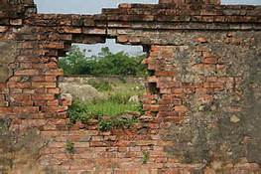
The Lord says, It's a new season. It's a new day so walk through the door of opportunity with Joy knowing that the Father has heard You.
Father God I thank You that a new direction has been raised up and we'll hear Your voice saying,"this is the way, walk in it my child." We are calling those things that aren't as though they are.
Father, I decree The Lord has gone before us this day and every day after to make a way where the there is no way. You have gone before us and we will follow Your lead. We will move as you move, speak as you speak, stand on YOUR word of the Window/Door/Gate.. Your hand shall touch and reach…. I decree that we will SEE all you have for us and our bloodlines in which this door of opportunity you have brought forth unto us in this year of Year of The Window….
The Father is saying the waiting period is over, the time of fulfillment and promise has come. It's appeared, been announced, take your best foot forward, it is movement time and the next few months will be found huge shifts people be found in the New and working in it, settled in and making progress.... You're in the door of obtaining the promise of what's been spoken to you. You've waited long, and endured patiently, just like Abraham did, But now I see, See the Door of fulfillment of suddenly opportunity, rags to riches, promised cross over is here! And multiplication of those Promises are released! Expansion has come and now is. It is Inheritance time children of the Lord. He has opened the door to Outcast, they will be gathered quickly, they will be sold out, set a blaze, they will carry awakened hearts… It The Open door to the Reserve and preserved has been brought forth, Now it is so. is vital we bind Fear, for Fear causes our hearing to not hear clear, it limits us in our hearing and cause a detour effect.
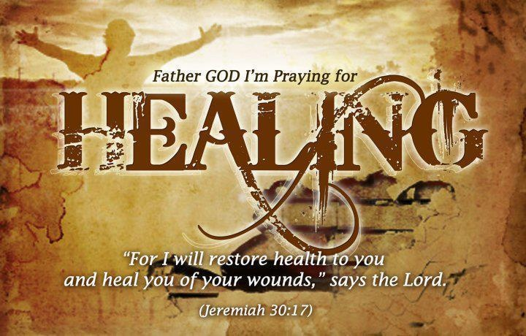
Jer 30:17-20 17 For I will restore health to you and heal you of your wounds,' says the LORD,'Because they called you an outcast saying:"This is Zion; No one seeks her."' 18 "Thus says the LORD: 'Behold, I will bring back the captivity of Jacob's tents, And have mercy on his dwelling places; The city shall be built upon its own mound, And the palace shall remain according to its own plan. 19 Then out of them shall proceed thanksgiving And the voice of those who make merry; I will multiply them, and they shall not diminish; I will also glorify them, and they shall not be small. 20 Their children also shall be as before, And their congregation shall be established before Me; And I will punish all who oppress them. NKJV

Restore= To be safe in mind or body, perfect, make completed, reciprocate, make amends, give again.
Health: wholeness a sense of restoring to soundness and wholeness
Wounds: beaten, stripped, blow
Heal: repair thoroughly-make whole, to mend by stitching
Outcast: banished, case down, mislead

We are in the place of the kingdom where there shall be great birthing in this Hour and the Man and the Woman shall be working hand in hand in the spirit! Do not pull back, wrap even closer, for this is beginning sign of a breaking of a fatherless generation. I am coming to gather my children, those who have been outcast, to restore all that is broken. I am about to move in a supernatural way in love, and melt even the hardest heats, and no longer will they be abandoned. They are the restored, fitly built together shall they be. They will come forth in an on a firm foundation of my love, and shall suffer no more. They shall be planted firmly in my family, in the Kingdom, and I will plant them in new families of my love Ps 68:5This is established this day as the beginning of this of which I created as I upon for 5778/ 2018 release upon the earth…

He started reminding me of a vision I had in 2010 and he began making it even more clear in the day which were entering… it is active now more than ever… He reminded me of this and said for such a time as this, will the vision be manifested, the outcast are coming home…

Vision: I just seen thousands of kids’ faces that had been distorted from rejection, hurts, pain, divorce, separation, molestation, abuse, dysfunction, abandonment, bastordship, addiction, etc. Then I see them each running to the reaching hand of a Father, that had been outreached unto them…. and as they ran, their faces became normal smiling faces of real joy, and then I see families forming in units of utter peace and happiness. All in the family were whole, New beginnings were everywhere, you could see them, you could see replacing of images taken place in their minds supernaturally by the Father, not one was left behind or separated, there is an anointing that shall rise out of the homes That the world has not seen because its pure love and expectance.
Beauty for the Ash truly came forth…

The Father started sharing with me about The Window-Doors-Gates……
That there will be open doors brought forth again.. These are the doors you shall see in the 20-18 time of Him! Doors that no one can shut :
Rev 3:7-10 "To the angel of the church in Philadelphia write: These are the words of him who is holy and true, who holds the key of David. What he opens no one can shut, and what he shuts no one can open. 8 I know your deeds. See, I have placed before you an open door that no one can shut. I know that you have little strength, yet you have kept my word and have not denied my name. 9 I will make those who are of the synagogue of Satan, who claim to be Jews though they are not, but are liars-I will make them come and fall down at your feet and acknowledge that I have loved you. 10 Since you have kept my command to endure patiently, I will also keep you from the hour of trial that is going to come upon the whole world to test those who live on the earth.

Doors in which we will see opening unto us beginning this 5778/2018 year… DOOR= As the opening for entering and leaving, it is an essential part of a tent or house. Portal, Entrance (the opening or closer) door-gate, OPPORTUNITY….

- Door of open pasture: John 10:9 I am the door: by me if any man enter in, he shall be saved, and shall go in and out, and find pasture. Pasture: feeding, the food…

- Doors of Utterance: Col 4:3 Withal praying also for us, that God would open unto us a door of utterance, to speak the mystery of Christ, for which I am also in bonds:

- Doors of Faith opened: Acts 14:27 And when they were come, and had gathered the church together, they rehearsed all that God had done with them, and how he had opened the door of faith unto the Gentiles.

- Doors of Supping : Rev 3:20-4:1 20 Behold, I stand at the door, and knock: if any man hear my voice, and open the door, I will come in to him, and will sup with him, and he with me.21 To him that overcometh will I grant to sit with me in my throne, even as I also overcame, and am set down with my Father in his throne. 22 He that hath an ear, let him hear what the Spirit saith unto the churches.

- Doors of Asking and Receiving= Matt 7:7-8 "Ask and it will be given to you; seek and you will find; knock and the door will be opened to you. 8 For everyone who asks receives; he who seeks finds; and to him who knocks, the door will be opened.
- Opportunities, witty inventions, dreams becoming reality, asking out of the heart of the Father will produce nothing but fullness of the spoken creative word, when you ask by the spirit in you there is a guarantee it shall be done for you for in this asking and knocking you’re asking and knocking from the spirit which is done as quickly as it is asked granted in full with all fullness:

- Doors of the greatest gifts of Heaven: Matt 7:9-12 "Which of you, if his son asks for bread, will give him a stone? 10 Or if he asks for a fish, will give him a snake? 11 If you, then, though you are evil, know how to give good gifts to your children, how much more will your Father in heaven give good gifts to those who ask him! 12 So in everything, do to others what you would have them do to you, for this sums up the Law and the Prophets.

- Doors of healing the sick in instant moments great miracles sings and wonders in whole towns not just a few but where the whole towns gather!
- Mark 1:32-34 That evening after sunset the people brought to Jesus all the sick and demon-possessed. 33 The whole town gathered at the door, 34 and Jesus healed many who had various diseases. He also drove out many demons, but he would not let the demons speak because they knew who he was.

- Door of messages: Col 4:2-4 Devote yourselves to prayer, being watchful and thankful. 3 And pray for us, too, that God may open a door for our message, so that we may proclaim the mystery of Christ, for which I am in chain
You can order products from our online store at: www.freedomfireministry09.com
[Sidebar Title]

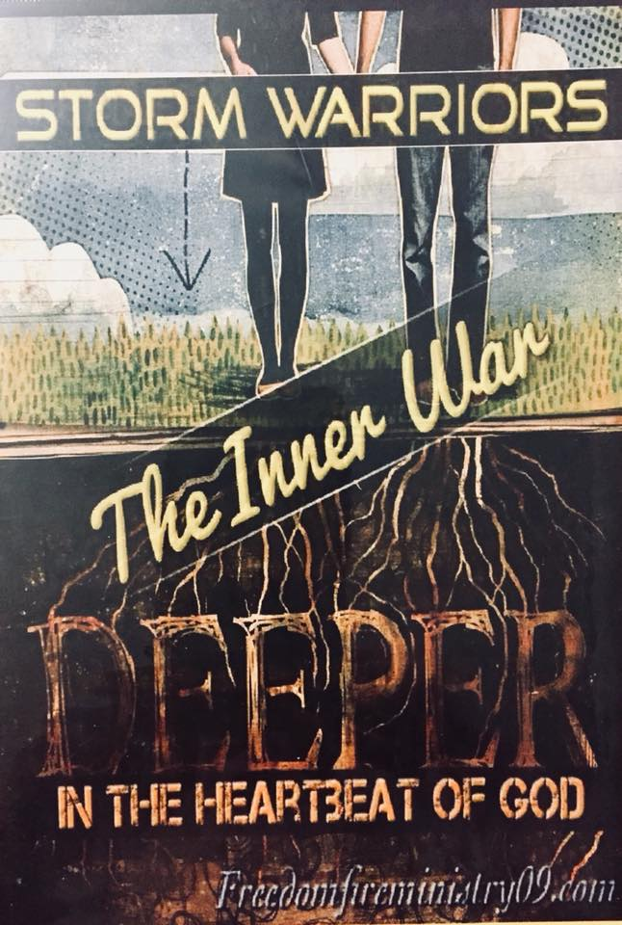
Partner Message of the Month

This month’s partner cd is: The Inner War, Deeper in the heartbeat of God. A 2 cd set for all our amazing partners here at FFM. If you would like to become a partner with this ministry, and help us to go across the world sharing the NOW word, touching lives, and making an impact upon the world through live broadcasting, serves, prison ministry and much more, sign up at Freedomfireministry09.com or you can simply text:: Give to 405-261-5446

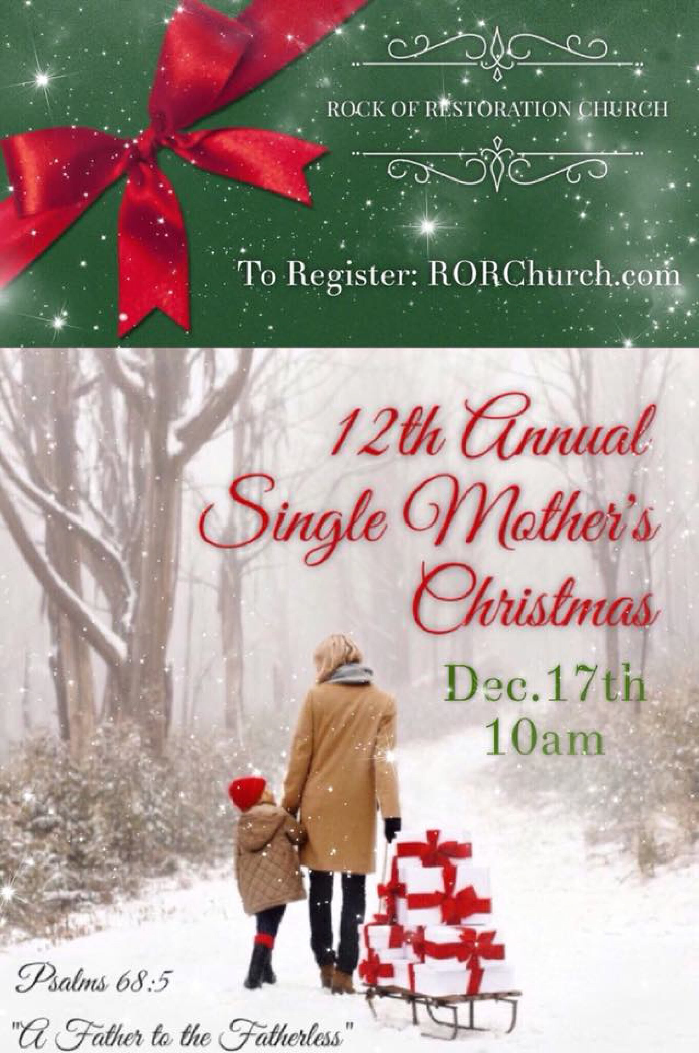
We will be going on the radio Oct 16th, Nov 13th and Dec11th at the Coyote radio broadcast out of Weatherford Ok, to share all about Single Mothers Christmas Event this year. Kristi is the Director of the Program, and has the honor every year to bring the Now word unto the single mothers. This will be RORC 12th year to bring about this amazing Event. Bringing Christmas to children of Single Parents. The last year will held SMC there was 268 Parents and 700 children in which we had the honor to bring forth a happy Holiday unto. Lives were touched, and Jesus was given all the glory. This Years event will be Dec 17th @ 10am. Applications will begin being available in Nov 2017 and one can sign up at: RORChurch.com

FFM Founders

Richard & Kristi Highwalker
Have a big announcement to make:

The Highwalkers are very happy to announce the baby is actually in the process of being birthed: They are in the delivery room now with the Newest addiction to the Highwalker family, it is Kristi’s book “ From the prison to the Pulpit”. This Is her biography of her life transformation She shares how she was raised in Church, grew up in a very close net family till the death of her mother at age 20 and at which time life began to crumb and fast. She found herself locked up in 8 major Prisons in her life before Jesus, that lead her to her final Prison in 1998 called Jail. The very same Jail in which she as a child walked the halls of, with her Daddy, which was a Blaine County Deputy Sheriff. In the book she shares her story of how Jesus touched her life right there in a Jail cell. Delivering her from Addiction and the power of Abuse, and began the process of her transformation. She shares how God can and will change a person’s life and deliver them from Death to Life, from loss to Recovery. She tells how Prison didn’t break her, it MADE her. After 8 years of major lose and 8 different types of Prisons formed, she found her way out from the Prisons to the Pulpit through Jesus Christ.. This is her record of that journey...Her story will inspire anyone who is trapped in Addiction, Abuse, Loss of loved ones, Divorce, Suicide, Rape, Rejection, Abandonment, Prison and self-destruction She is in the final stages of writing now, and we look for it to be published (birthed) and available to order by March 2018

Kristi is also in the midst of writing her second book called: Fear is it’s name and no longer my Game: How to dismantle the Stronghold of Fear, understanding exactly what all forms from this stronghold and how to develop the perfect love which cast out all fear. Truly living a life of Freedom, begins with demolishing this spirit. One must begin to cultivate and develop the fruit of Love and a deep relationship with the Father in order to truly demolish this spirit off one’s life. Ones rooted in Bondage and Infirmity will find how this book will bring them step by step teaching and understanding of how to come out and remain free. Look for it mid 2018.

The Highwalkers are the publishers for Richard's first book called "Christ Anointed Garage" printed in March 2008. Which they hope to bring back into print in 2018 as well.

Kristi Looks forward to bringing in late 2018 early 2019 the book burning in her belly called: The Power of Submission, which is a book about how the Lord lead Kristi out of the wrong submission of Abuse, she will bring some insight into the mind of an abused woman and the power of which the abuser held in her mindset, and how it formed a wrong submission unto man which lead her into a prison in her mind that as unbearable and twisted. Causing submission to abuse and her abuser. Completely loosing herself in the torment of man. As she will share in the book how Jesus took that traumatic time in her life and turned it around into a life in which as able to submit unto the Father and His Will and ways and all the Benefits of which her life experienced from the Power of aligned Submission unto the Father… the Beauty of the Ash effect in her mindset. This will be a powerful book that will help family members which have a loved one trapped in the prison of abuse and one cannot understand why they stay, as well as give hope to the one in the prison of their abuser see they can get out! It is a process and she will share her process in this book with the world. It will help in showing how when that mindset is touched by the Heavenly Father and untwisted, Kristi shares how because of the abuse in her life and the lessons from that time she gained after touched by the Father and made correct. How submission unto the Father was easy for her. Not that she always does right, but true submission commanding her flesh in order to develop the fruits of the spirit and the real relationship with the Lord became easy. It is truly a story of the Beauty from the Ash.

Along with other books that you can look forward to coming out beginning mid to late 2018-2019 by the Highwalkers will be: "The Fathers love inside of her belly",: "Coming from the grave to Greatness", The Great Exchange, The Storm Warriors MO. And the Biography of Richard Highwalkers life story called: The Damascus Road Experience

They are marketing more publications, gifted by the Holy Spirit to publish their Publications for God's kingdom. Richard illustrates his drawing from each message they preach in their meetings. You will receive the written word, spoken word and the visual word. The Highwalkers are anointed to speak in conferences and gifted in the Holy Spirit walking in the fullness of their prophetic gifts and the office of a Prophet.

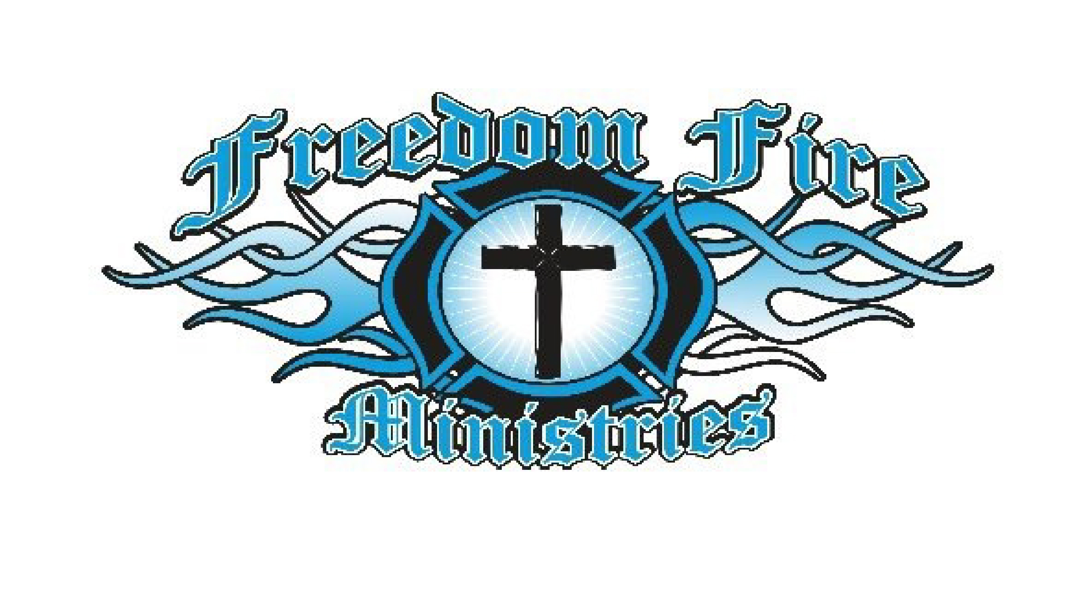
Partnership
Your partnership is needed! Please send your monthly donation to the address below. When you partner with Freedom Fire Ministries you will be receiving back 100 fold. For this is solid ground, built upon the rock of truth and the rock of Jesus Christ and his whole word amen.
Freedom Fire Ministry Inc
P.O. Box 350
Calumet, Ok 73014
(405)358-FIRE
kristi@freedomfireministry09
www.freedomfireministry09
HOW DO I BECOME A COVENANT PARTNER?
Very simply click go to the webpage and click partner at the bottom of the page: WE ARE READY TO GO AND GROW! Or you may simple send us a Text a donation to the below information and sign up for partnership.
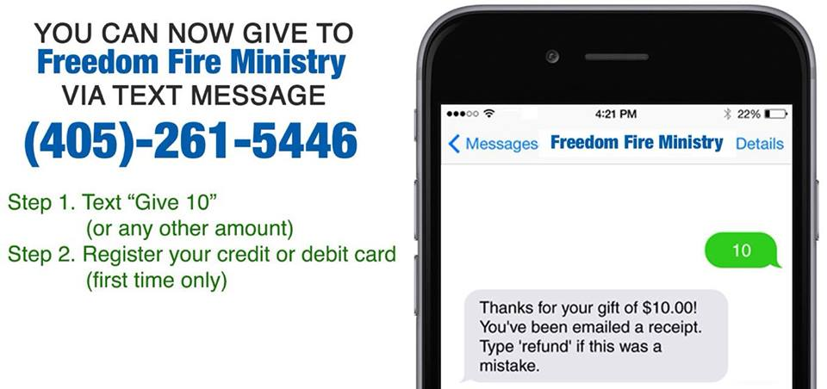
Upon becoming a monthly partner with FFM, you will receive this monthly newsletter along with a cd of the message of the month. Which will be delivered into your email box every month. Or mailed to you directly. We will be starting in January 2018 having a partner only page which you will sign up for and get a password and you can then go online and listen to your CD of the Month.
Once you sign up to be a Covenant partner with Freedom Fire Ministries from our webpage, you will be sent a partner kit. www.freedomfireministry09.com
Allow 1-3 weeks for processing for New Covenant Partners.
From our heart , The Highwalkers and all at Freedom Fire Ministry, thank you for your kindness, your attention, and your help, in reaching out to the world for Jesus, and building a strong church to win the lost.

It is time to be the illumination of the anointed Messiah. To take your city, to be the established end time explosion of the Father, that the world is looking for. It is time to dismantle Jezebel, Baal, and Leviathan in one’s hearts, one’s city, and one’s county, on to one’s state, and then the USA….

We will offer such teaching and insight that will establish all it is sent to do. Eyes have not seen nor did ears hear of this establishing Rhema of the Kingdom of God, which actually brings in the Heaven lies here on Earth. We will teach how to maintain, and to go, and grow, in the fullness with all joy and establishment.

But we cannot do this all alone… It takes you as Leaders, & Partners to help us fulfill this Kingdom Call…. How?
- By heeding the call of the Spirit to open the door unto us, to come and release the spoken NOW word of God
- By partnering with us, and the vision the Father has granted. (Not all can go but all can partake threw partnership, prayers, encouragement, it will take many to fulfill this not just Richard and I…. We need the body of Christ to heed the call to stand with us and work beside us and us beside them)

FFM is a faith based and ran ministry, trusting of he called us, He will provide the way and one way he does that is by sending those who heed the voice of the Father and partner with FFM. All donations are tax deductible....

If you’re a church, ministry, etc and would like the Highwalkers to come to your place, or your event ,we are taking bookings now for 2018 To our already Partners, What a blessing to know of your desire to partner with this ministry, as we reach out to touch Lives for the Kingdom! Hearts will be changed, and will be set free because of you, and know that you are an answer to our prayers. We believe that there are great benefits to being involved in God’s plan for world evangelism. Together we are planting seeds of harvest into souls, and we know that we will see a great harvest of lives for Christ. Because of you will be able to bring Luke 4:18 across to every person in the path of the journey that the Lord has us on. You shall reap back a great Harvest for sending us into the Field.

