Kristi Highwalker Ministry
Fire Tribe Global Academy
www.KrisitHighwalker.com
405-938-7159

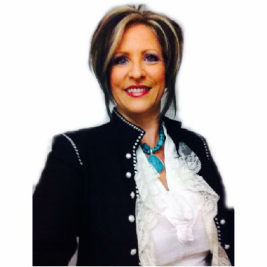
Apostle Kristi Highwalker is currently today Co-Founder of Freedom Fire Ministry, Founder of Kristi Highwalker Ministry, and Miracle Hands Productions, Director of Overcomers of Western Ok, Host of Fresh Fire Online Broadcast as well as the RAW weekly broadcasting, and Co- Founder of Fire Tribe Global Academy.

Kristi Is a celebrated author and teacher, a much sought out speaker, devoted Wife, beloved Nana, Mother, and Mentor, Entrepreneur and spirit-led- Preacher of God’s word. All of the Ministries under the Umbrella of FFM are under the covering of Apostle Ryan Lestrange.
Kristi Highwalker is a minister focused on bringing truth and freedom to each and every person who has fallen in life. Kristi’s message is one of Hope and Restoration, emphasizing how to overcome even the most traumatic falls in life.
Kristi is an overcomer in a life full of severe trauma including the loss of her children and entire family in the midst of a prison sentence. She is a survivor and Overcomer of severe abuse and drug addiction. Kristi has walked the journey as an overcomer successfully.
Kristi is married to the love of her life Richard Highwalker, who she walks in all aspects of ministry and life with. The Highwalkers have 4 children, and 8 Grandchildren.
In the love of the Father
Kristi Highwalker

